
COURSE-END PROJECT REPORT
On
Exploratory Data Analysis and Train Passenger Travel Pattern Analysis
Submitted to fulfill the requirements for the Award of CIE Marks (10) for the B.E.(IT), III-SEM, Course:
Exploratory Data Analysis & Visualization - EDAV (22ADC32N)
By
RAKESH NALLA
160125737112
Under the guidance of
Mr. G. Srikanth
Assistant Professor, Dept. of IT, CBIT

CHAITANYA BHARATHI INSTITUTE OF TECHNOLOGY (CBIT)
DEPARTMENT OF INFORMATION TECHNOLOGY (IT)
KOKAPET (V), GANDIPETA, RANGA REDDY, HYDERABAD – 500075
www.cbit.ac.in
A.Y: 2026-27
CERTIFICATE
This is to certify that the course-end project report entitled “Exploratory Data Analysis and Train Passenger Travel Pattern Analysis” is a bonafide record of the work carried out by RAKESH NALLA (160125737112), in partial fulfilment of the requirements of the course Exploratory Data Analysis and Visualization (22ADC32N) of the programme B.E(IT), III-SEM, during the academic year 2026–2027.
The project was carried out under my guidance and supervision. To the best of my knowledge, the work reported here is original and has not been submitted to any other institution or university for the award of any degree, diploma or certificate.
Place: Hyderabad
Date: ___/___/_____
Course Faculty
(Mr. G. Srikanth)
Assistant Professor, Dept. of IT, CBIT
DECLARATION
I hereby declare that the project report entitled “Exploratory Data Analysis and Train Passenger Travel Pattern Analysis” submitted to Dept of IT, CBIT is a record of original work done by me under the guidance of Mr. G. Srikanth, Assistant Professor, IT, CBIT.
The data used was taken from the Train Ticket Sales India dataset (train_ticket_sales_india.csv) used for the course; all external sources, tools and libraries have been acknowledged in the References. This work has not been submitted, in part or in full, for any other course, degree or diploma.
Place: Hyderabad
Date: ___/___/_____
______________________________
Signature of the Student
RAKESH NALLA (160125737112)
ACKNOWLEDGEMENT
I express my sincere gratitude to my project guide and course faculty, Mr. G. Srikanth, Assistant Professor, Dept. of IT, CBIT, for valuable guidance, encouragement and constructive feedback throughout this project.
I thank the Head of the Department, the faculty members and the management of Chaitanya Bharathi Institute of Technology (CBIT) for providing the facilities and the learning environment that made this work possible.
I am also grateful to the open-source community behind Python, pandas, NumPy, Matplotlib and Seaborn, and to the publishers of the Train Ticket Sales India dataset, without which this analysis would not have been possible. Finally, I thank my family and friends for their constant support.
Rakesh Nalla
Contents
S.No. | Item | Page No
 | Abstract | 6
1 | Introduction | 7
2 | Problem Statement and Objectives | 7
3 | Dataset Description | 8
4 | Methodology and Tools | 8
5 | Data Quality Assessment and Cleaning | 9
6 | Exploratory Data Analysis | 10
7 | Visualization and Distribution Analysis | 16
8 | Station and Route Demand Analysis | 19
9 | Key Findings | 21
10 | Recommendations | 22
11 | Limitations | 22
12 | Conclusion | 23
13 | Future Scope | 23
 | References | 24
 | Appendix A – Notebook (ipynb) File | 25
 | Appendix B – How to Run | 32
Abstract
Rail travel is the backbone of passenger movement in India, and the tickets sold by a railway network record who travels, between which stations, in which coach class and at what price. This project analyses the Train Ticket Sales India dataset of 8,000 ticket records sold between January 2023 and September 2025, of which 6,738 valid records remain after cleaning, to understand how passenger demand, ticket price and payment behaviour vary with route, coach type, passenger age and time.
The work follows an end-to-end data analysis workflow in Python: dataset loading, data-quality assessment and cleaning (harmonising station codes and labels, removing journeys whose source and destination are the same), feature engineering (route, age group, price level, payment code and price rank), Pandas indexing, merging, pivoting and group-by analysis, time-series resampling, NumPy statistical analysis, and visualization with Matplotlib and Seaborn (line, bar, histogram, scatter, box and violin plots, a route heat map and a pair plot).
Main results. Sleeper is the most booked coach (3,380 tickets, 50.2%), followed by General (1,965; 29.2%) and AC (1,393; 20.7%). Ticket price is determined mainly by coach class: the mean price is Rs. 2,016.30 for AC, Rs. 897.84 for Sleeper and Rs. 349.82 for General, with maximum prices of Rs. 2,500, Rs. 1,200 and Rs. 500. AC accounts for 20.7% of tickets but about 43.0% of ticket revenue. The overall mean ticket price is Rs. 969.25 (median Rs. 844). Demand is concentrated on the Delhi, Mumbai and Chennai corridors: each of the six directed routes between these three cities carries between 314 and 337 tickets, and the three cities together are the source of 57.6% of all tickets. Passenger age is spread almost evenly between about 5 and 80 years and shows no visible relation with price. Monthly ticket revenue fluctuates between roughly Rs. 170,000 and Rs. 215,000 without a clear long-term trend.
Keywords: railway passenger analysis; exploratory data analysis; ticket sales; route demand; pandas; NumPy; Matplotlib; Seaborn.

1. Introduction
Railways are the most widely used long-distance mode of travel in India. Every ticket sold records a small piece of travel behaviour: the day it was bought, the two stations it connects, the age of the passenger, the class of coach and the price paid. Taken together, thousands of tickets show which routes are busy, which coach classes passengers prefer and how revenue moves through the year. These are practical questions for railway planners, who must decide how much capacity to provide, how to mix coach classes and where to improve passenger services.
The available data records, for every ticket, a ticket ID, the sale date, the source and destination station, the passenger age, the coach type, the ticket price and the payment mode. Such data is well suited to a teaching project because it needs every stage of a real analysis: loading, inspecting, cleaning, transforming, indexing and merging, grouping, resampling over time, visualizing and drawing conclusions. Its imperfections mirror those of real transaction data: the same station is recorded both as a city name and as a station code (for example BCT, MAS, NDLS, HWH and SBC), the payment label NetBanking is written without a space, and some tickets have the same source and destination.
This report describes the analysis carried out in the companion Jupyter notebook (Appendix A). Every table and figure in the report is taken from, or computed directly from, the outputs of that notebook, so the results can be reproduced. Where the notebook does not contain a result (for example the number of tickets per payment mode), the report says so instead of estimating it.

2. Problem Statement and Objectives
Problem statement. To analyse the Train Ticket Sales India dataset in order to describe how ticket demand, ticket price and payment behaviour vary across routes, stations, coach types, passenger age groups and time, and to identify the travel patterns that can support railway planning and passenger services.

2.1 Objectives
- Load the dataset and examine its structure, data types and quality.
- Clean the data by harmonising station codes and labels, converting data types, checking for missing values and duplicates and removing journeys whose source and destination are identical.
- Create derived features: route, age group, price level, price rank and a numeric payment code.
- Summarise tickets and prices with Pandas selection, indexing, merging, pivoting and group-by analysis.
- Analyse ticket revenue over time by resampling the sale dates.
- Compute statistical summaries and array operations with NumPy.
- Create Matplotlib and Seaborn visualizations (line, bar, histogram, scatter, box, violin, heat map and pair plot) and interpret them.
- Identify the busiest routes and stations and derive findings and recommendations.

2.2 Research questions
- How are tickets distributed over coach types, and how much revenue does each coach type contribute?
- How does the ticket price vary with coach type, source station, payment mode and passenger age?
- Which routes and stations carry the most passengers?
- What is the age profile of the passengers?
- How does monthly ticket revenue change between January 2023 and September 2025?

3. Dataset Description
The analysis uses the file train_ticket_sales_india.csv, which is uploaded into Google Colab at the start of the notebook. According to the notebook, the file holds 8,000 ticket records sold between January 2023 and September 2025 in 8 columns. After cleaning, 6,738 tickets remain; they connect 7 cities (Bengaluru, Chennai, Delhi, Gorakhpur, Jaipur, Kolkata and Mumbai), use 3 coach types (General, Sleeper and AC) and are paid for in 4 ways (Cash, UPI, Card and Net Banking). Each row describes one ticket. The currency of the ticket price is not stated in the file; Indian Rupees (Rs.) are assumed in this report. The original source of the file is not stated in the notebook (the cell contains the placeholder “add dataset link here”) and should be cited by the student in the final submission.
Table 1: Columns of the dataset (train_ticket_sales_india.csv)
Column | Type | Description
Ticket_ID | Number | Serial number of the ticket record
Sale_Date | Date | Date on which the ticket was sold (converted from text to datetime during cleaning)
Source_Station | Text | Station where the journey starts; city name or station code before cleaning
Destination_Station | Text | Station where the journey ends; city name or station code before cleaning
Passenger_Age | Number | Age of the passenger in years
Coach_Type | Text | Class of coach: General, Sleeper or AC
Ticket_Price | Number | Price of the ticket (converted to a decimal number during cleaning)
Payment_Mode | Text | Mode of payment: Cash, UPI, Card or Net Banking (written NetBanking in the raw file)

The data contains no train number, journey date or time, travel distance or seat information. The analysis is therefore restricted to what the eight columns can show: demand by route and station, price by coach class, the age profile of passengers, payment behaviour and ticket revenue by sale date.

4. Methodology and Tools
The project follows a seven-step pipeline: (1) set up the environment and load the dataset, (2) inspect the data, (3) clean it, (4) derive new features, (5) index, merge, reshape and group the data, (6) analyse it over time and with NumPy and visualize the results, and (7) synthesise the findings. Every step is implemented in the companion notebook (Appendix A), so the results are reproducible. The notebook sections are listed in Table 3.
Table 2: Libraries used
Purpose | Library
Numerical statistics and arrays | NumPy (mean, median, standard deviation, arrays, broadcasting, matrix product, random numbers)
Data handling, group-by and time series | pandas (read_csv, replace, drop_duplicates, cut, qcut, merge, pivot, groupby, resample)
Basic charts | Matplotlib (subplots, line plot, bar chart, histogram, scatter plot)
Statistical charts | Seaborn (box plot, violin plot, heat map, pair plot)
File upload in Google Colab | google.colab.files (upload of the CSV file)

Table 3: Notebook sections and main techniques
Section | Task | Main techniques
Setup and loading | Import libraries, upload and read the CSV file | read_csv, files.upload
Pandas basics | Series and DataFrame creation, selection of rows and columns | Series, DataFrame, loc, iloc, Boolean filter
Cleaning | Missing values, station codes, labels, data types, duplicates, invalid journeys | isnull, fillna, dropna, replace, to_datetime, drop_duplicates
Transformation | Derived columns, sorting and querying | map, cut, qcut, rank, sort_values, query
Indexing and merging | Hierarchical index, concatenation, merge, reshaping | set_index, concat, merge, pivot, stack, unstack
Group-by and time series | Group summaries, monthly and weekly resampling | groupby, agg, resample, date slicing
Matplotlib | Four-panel figure | subplots, plot, hist, scatter
Seaborn | Box, violin, heat map and pair plot | boxplot, violinplot, heatmap, pairplot
NumPy | Arrays, indexing, broadcasting, statistics | arange, reshape, mean, median, std

Key technical choices: station codes are replaced by city names with a dictionary so that each city has one label; journeys whose source and destination are the same are removed as invalid; ticket prices are converted to decimal numbers and sale dates to datetime values so that the data can be resampled by month; passengers are grouped into four age groups with pd.cut and ticket prices into three levels with pd.qcut; and monthly ticket revenue is obtained by summing ticket prices over calendar months.

5. Data Quality Assessment and Cleaning
The data was checked before analysis. The issues found and the treatment adopted are summarised in Table 4. The notebook did not change genuine observations; it only harmonised labels, converted data types and removed invalid journeys.
Table 4: Data-quality issues and treatment
Issue | Evidence | Treatment
Missing values | isnull().sum() is 0 for all 8 columns | Median fill for age and dropna on price were applied as safeguards; no value changed
Duplicate rows | duplicated().sum() is 0 | drop_duplicates applied; no row removed
Station recorded as code | Codes BCT, MAS, NDLS, HWH and SBC appear beside city names | Replaced by Mumbai, Chennai, Delhi, Kolkata and Bengaluru
Inconsistent payment label | NetBanking written without a space | Replaced by Net Banking
Wrong data types | Sale_Date is text; Ticket_Price is an integer | Converted to datetime and to float
Same source and destination | Rows such as Delhi to Delhi (ticket 5) | Removed; 6,738 of 8,000 rows remain (1,262 removed)

After cleaning, five columns were added by the notebook: Pay_Code, Route, Age_Group, Price_Level and Price_Rank (Table 5). Column names of the original file were kept. The age groups use right-inclusive bins, so an age of exactly 18 falls in the Child group.
Table 5: Derived columns
Column | Definition | Values
Pay_Code | Numeric code of the payment mode (map) | Cash 0, UPI 1, Card 2, Net Banking 3
Route | Source_Station + " - " + Destination_Station | For example Bengaluru - Delhi
Age_Group | pd.cut of Passenger_Age with bins 0, 18, 35, 60, 100 | Child, Young, Adult, Senior
Price_Level | pd.qcut of Ticket_Price into three equal-sized groups | Low, Medium, High
Price_Rank | Rank of the ticket price in descending order; ties receive the average rank | Number from 1 to 6,738

The first five raw records (Table 6) show why cleaning was needed: stations appear as codes (SBC, BCT, HWH) and ticket 5 starts and ends in Delhi. Table 7 shows the first three cleaned records with the two derived columns Pay_Code and Route.
Table 6: First five raw records (before cleaning)
ID | Sale date | Source | Destination | Age | Coach | Price (Rs.) | Payment
1 | 2023-01-01 | SBC | Delhi | 24 | Sleeper | 1,065 | Cash
2 | 2023-01-01 | Mumbai | Chennai | 46 | General | 338 | Cash
3 | 2023-01-01 | SBC | Mumbai | 76 | General | 420 | UPI
4 | 2023-01-01 | BCT | HWH | 38 | Sleeper | 872 | UPI
5 | 2023-01-01 | Delhi | Delhi | 54 | AC | 1,653 | UPI

Table 7: First three cleaned records with derived columns
ID | Sale date | Source | Destination | Age | Coach | Price (Rs.) | Payment | Pay_Code | Route
1 | 2023-01-01 | Bengaluru | Delhi | 24 | Sleeper | 1,065 | Cash | 0 | Bengaluru - Delhi
2 | 2023-01-01 | Mumbai | Chennai | 46 | General | 338 | Cash | 0 | Mumbai - Chennai
3 | 2023-01-01 | Bengaluru | Mumbai | 76 | General | 420 | UPI | 1 | Bengaluru - Mumbai

The effect of the cleaning steps on the size of the data is summarised in Table 8. Since no duplicates and no missing values were found, all 1,262 removed rows are the journeys with identical source and destination, which is 15.8% of the raw records. The row counts are taken from the notebook: 8,000 raw records (stated in the first cell) and 6,738 after cleaning (output of the cleaning cell).
Table 8: Effect of cleaning on the dataset
Stage | Rows | Columns | Missing values
Raw file | 8,000 | 8 | 0
After cleaning (duplicates, same-station journeys) | 6,738 | 8 | 0
After adding the derived columns | 6,738 | 13 | 0

One limitation of the duplicate check should be noted: because every record carries a unique Ticket_ID, drop_duplicates compares whole rows including the ID and can never find a repeated booking. Duplicates were therefore not detected in a meaningful sense.

6. Exploratory Data Analysis

6.1 Pandas basics and data selection
The notebook first builds a Series from the first five ticket prices with the labels t1 to t5, and a small look-up DataFrame that assigns a numeric level to every coach type (General 1, Sleeper 2, AC 3). Both are shown below; the look-up table is used again in the merge operation of Section 6.3.
Table 9: Pandas Series of the first five ticket prices
Label | t1 | t2 | t3 | t4 | t5
Ticket price (Rs.) | 1,065 | 338 | 420 | 872 | 1,653

Table 10: Coach-type look-up DataFrame
Coach_Type | Level
General | 1
Sleeper | 2
AC | 3

Label-based selection with loc and position-based selection with iloc return the source, destination and price of the first five tickets, and the first four columns of the first five rows. A Boolean filter then keeps the tickets priced above the mean. Table 11 shows the first five of them; all are Sleeper or AC tickets, which is expected because General tickets never reach the mean price (Section 6.4). These outputs were produced before the cleaning step, so station codes still appear.
Table 11: First five tickets priced above the mean (before cleaning)
ID | Source | Destination | Age | Coach | Price (Rs.) | Payment
1 | SBC | Delhi | 24 | Sleeper | 1,065 | Cash
5 | Delhi | Delhi | 54 | AC | 1,653 | UPI
6 | Mumbai | SBC | 15 | AC | 1,748 | Cash
7 | HWH | Gorakhpur | 47 | AC | 1,778 | UPI
9 | MAS | Mumbai | 12 | Sleeper | 1,113 | NetBanking

6.2 Data transformation and feature engineering
Sorting the cleaned data by ticket price in descending order gives the five most expensive tickets (Table 12). All five are AC tickets sold to passengers aged between 14 and 61 years, on three different routes from or to Gorakhpur, Delhi and Chennai. Three tickets share the maximum price of Rs. 2,500, and the next group of tied tickets at Rs. 2,499 has an average rank of 5.0, which shows that tied prices receive the mean of their ranks.
Table 12: Five highest ticket prices (sorted with sort_values)
ID | Sale date | Route | Age | Coach | Price (Rs.) | Payment | Age group | Rank
7591 | 2025-08-04 | Gorakhpur - Delhi | 32 | AC | 2,500 | Cash | Young | 2.0
4746 | 2024-08-15 | Gorakhpur - Jaipur | 27 | AC | 2,500 | Net Banking | Young | 2.0
2422 | 2023-10-30 | Delhi - Jaipur | 14 | AC | 2,500 | Cash | Child | 2.0
7802 | 2025-08-31 | Delhi - Mumbai | 61 | AC | 2,499 | Cash | Senior | 5.0
2119 | 2023-09-22 | Chennai - Gorakhpur | 31 | AC | 2,499 | Cash | Young | 5.0

The query Age_Group == “Senior” and Price_Level == “High” selects senior passengers who bought high-priced tickets (Table 13). The result contains both AC tickets and Sleeper tickets priced above Rs. 1,000, so the upper price tercile includes the upper part of the Sleeper range as well as all AC tickets; the boundary of the High level therefore lies below Rs. 1,055.
Table 13: Senior passengers with high-priced tickets (first five results of query)
ID | Sale date | Route | Age | Coach | Price (Rs.) | Payment
32 | 2023-01-04 | Kolkata - Jaipur | 71 | AC | 1,860 | UPI
37 | 2023-01-05 | Mumbai - Delhi | 69 | Sleeper | 1,055 | Net Banking
39 | 2023-01-05 | Mumbai - Chennai | 68 | Sleeper | 1,065 | UPI
43 | 2023-01-06 | Jaipur - Chennai | 77 | AC | 1,972 | UPI
47 | 2023-01-06 | Gorakhpur - Mumbai | 61 | Sleeper | 1,121 | Card

6.3 Indexing, merging and reshaping
Setting Source_Station and Destination_Station as a hierarchical (MultiIndex) index and sorting it allows all tickets of one source city to be selected with a single call. multi.loc[“Delhi”] returns the tickets that start in Delhi, grouped by destination; the first rows are Delhi to Bengaluru tickets (Table 14).
Table 14: First rows of multi.loc["Delhi"] (Delhi to Bengaluru tickets)
Ticket_ID | Sale date | Age | Coach | Price (Rs.) | Payment | Age group | Price level
12 | 2023-01-02 | 69 | General | 329 | Cash | Senior | Low
56 | 2023-01-07 | 68 | General | 232 | UPI | Senior | Low
100 | 2023-01-13 | 75 | AC | 2,197 | Cash | Senior | High
137 | 2023-01-17 | 68 | Sleeper | 714 | Card | Senior | Medium
278 | 2023-02-04 | 34 | Sleeper | 916 | Cash | Young | Medium

Concatenating the first three and the last three rows with pd.concat gives a table of 6 rows and 13 columns. Merging the data with the coach-level look-up table on Coach_Type (a left join) keeps all 6,738 rows and adds one column, Level, so the merged table has 6,738 rows and 14 columns; the first five levels are 2, 1, 1, 2 and 3 (Sleeper, General, General, Sleeper and AC). No rows were duplicated or lost by the merge.
The mean ticket price of every source station and coach type was computed with groupby and reshaped into a table with pivot (Table 15). pv.stack() turns this table back into a long series with one value per station and coach type, and unstack() restores the wide form. Figure 1 shows the same values as grouped bars.
Table 15: Mean ticket price by source station and coach type (Rs., rounded)
Source station | AC | General | Sleeper
Bengaluru | 2,005 | 346 | 896
Chennai | 2,052 | 346 | 909
Delhi | 2,013 | 349 | 899
Gorakhpur | 1,998 | 352 | 894
Jaipur | 2,014 | 357 | 894
Kolkata | 2,014 | 349 | 899
Mumbai | 2,003 | 352 | 891

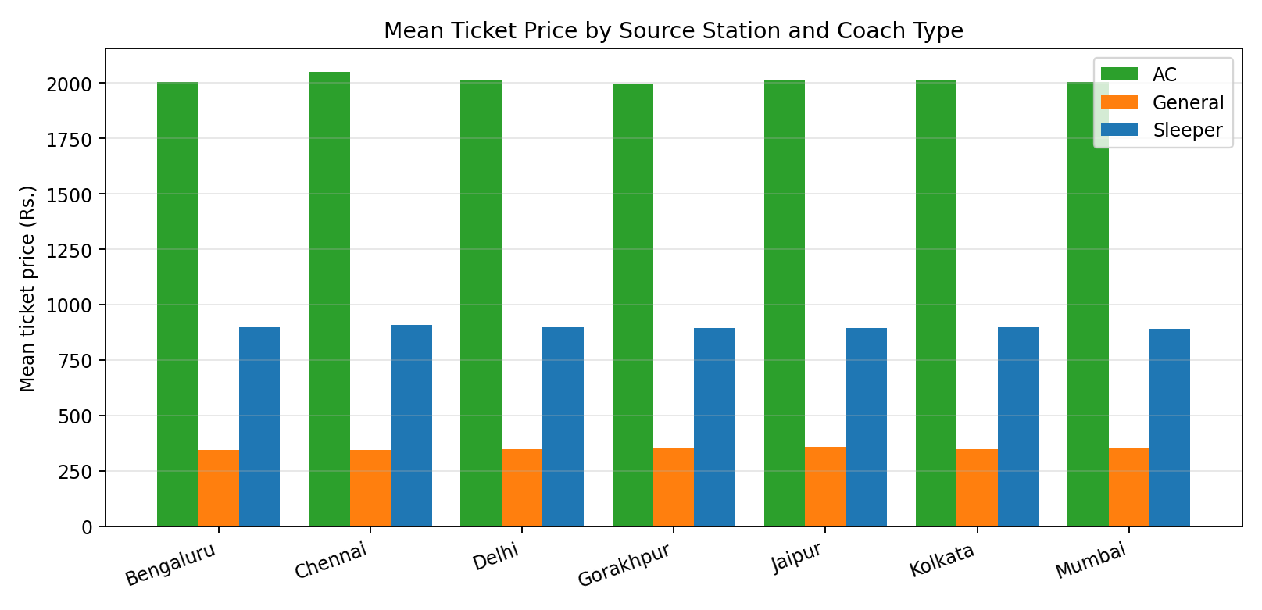
Figure 1: Mean ticket price by source station and coach type.
The price of a ticket hardly depends on the station where the journey starts: the mean AC price lies between Rs. 1,998 and Rs. 2,052, the mean Sleeper price between Rs. 891 and Rs. 909 and the mean General price between Rs. 346 and Rs. 357. Chennai has the highest mean AC and Sleeper prices, but the differences between stations are small compared with the differences between coach types.

6.4 Group-by analysis
Grouping the tickets by coach type gives the count, the mean price and the maximum price of each class (Table 16). Sleeper is the most frequently booked coach with 3,380 tickets, followed by General (1,965) and AC (1,393). The mean price rises from Rs. 349.82 for General to Rs. 897.84 for Sleeper and Rs. 2,016.30 for AC, and the maximum price of each class (Rs. 500, Rs. 1,200 and Rs. 2,500) is far from the minimum of the next class, so the three price ranges do not overlap.
Table 16: Tickets and prices by coach type
Coach type | Tickets | Mean price (Rs.) | Maximum price (Rs.)
AC | 1,393 | 2,016.30 | 2,500
General | 1,965 | 349.82 | 500
Sleeper | 3,380 | 897.84 | 1,200

Multiplying the number of tickets by the mean price of each class gives the ticket revenue of the class (Table 17). These figures are derived from the notebook output; their sum, Rs. 6,530,806, equals the overall mean price (Rs. 969.25) multiplied by the 6,738 tickets, which confirms the calculation. AC contributes 43.0% of the revenue with only 20.7% of the tickets, whereas General contributes only 10.5% of the revenue with 29.2% of the tickets (Figure 2).
Table 17: Share of tickets and ticket revenue by coach type (derived)
Coach type | Tickets | Share of tickets | Revenue (Rs.) | Share of revenue
Sleeper | 3,380 | 50.2% | 3,034,700 | 46.5%
General | 1,965 | 29.2% | 687,398 | 10.5%
AC | 1,393 | 20.7% | 2,808,708 | 43.0%
Total | 6,738 | 100.0% | 6,530,806 | 100.0%

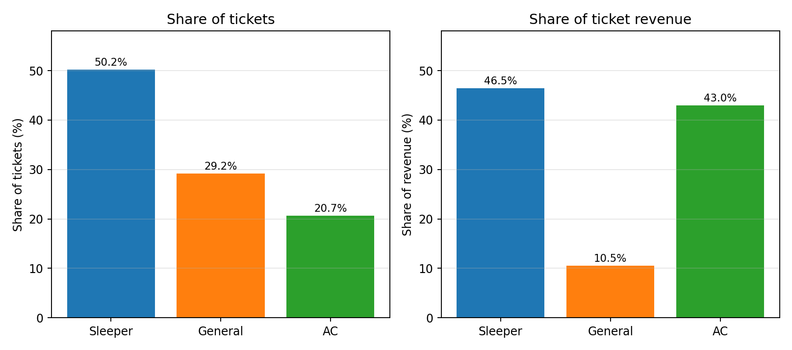
Figure 2: Share of tickets and share of ticket revenue by coach type.
The notebook also computes the mean ticket price for every combination of payment mode and age group (Table 18 and Figure 3). The values lie between Rs. 899.17 (Cash, Adult) and Rs. 1,024.54 (Net Banking, Young), within about 7% of the overall mean of Rs. 969.25 on either side, and no payment mode is consistently cheaper or dearer than another. The tickets per payment mode and per age group are not counted in the notebook, so a statement about how many passengers use each payment mode cannot be made from the notebook outputs.
Table 18: Mean ticket price (Rs.) by payment mode and age group
Payment mode | Child | Young | Adult | Senior
Card | 1,015.25 | 946.65 | 1,011.51 | 978.21
Cash | 956.17 | 1,003.05 | 899.17 | 965.97
Net Banking | 963.49 | 1,024.54 | 943.84 | 958.69
UPI | 922.06 | 970.36 | 987.61 | 969.41

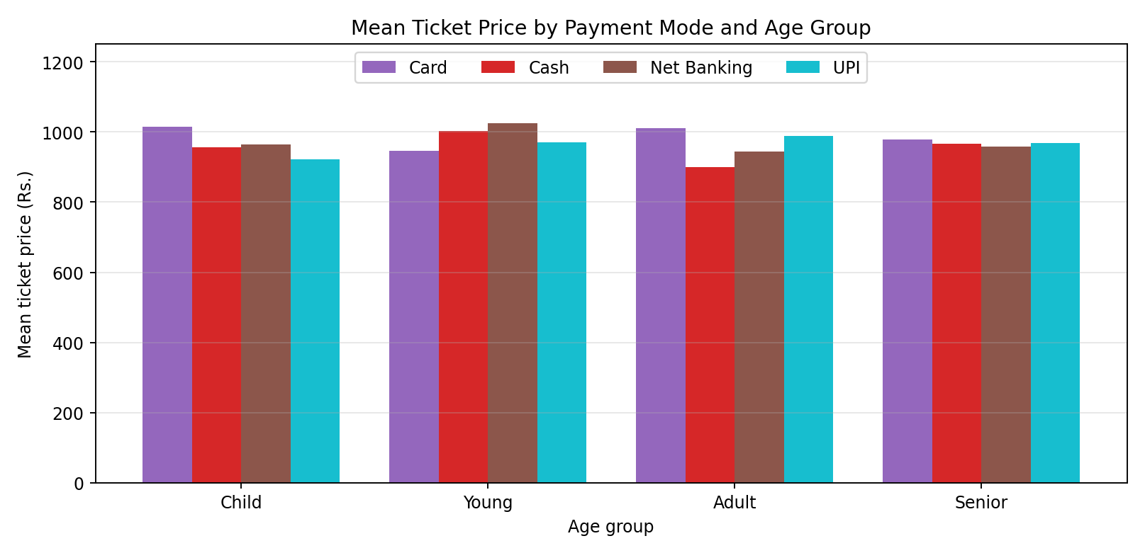
Figure 3: Mean ticket price by payment mode and age group.

6.5 Time-series analysis
For the time-series analysis the sale date is set as the index and the data is sorted by date. Ticket prices are then summed by calendar month with resample("ME") to give the monthly ticket revenue, and averaged by week with resample("W") to give the weekly mean price; the weekly series is computed in the notebook but is not displayed or plotted. Table 19 shows the monthly revenue of the first five months. It stays between Rs. 196,739 and Rs. 208,642, with the highest value in January 2023 and the lowest in May 2023. The complete series is plotted in Figure 4 (Section 7.1).
Table 19: Monthly ticket revenue, January to May 2023 (resample sum)
Month | Jan 2023 | Feb 2023 | Mar 2023 | Apr 2023 | May 2023
Ticket revenue (Rs.) | 208,642 | 198,804 | 207,156 | 204,980 | 196,739

Because the date is the index, a slice such as ts.loc["2024-01":"2024-03"] returns all tickets of the first quarter of 2024. The first five rows of this slice are the tickets sold on 1 January 2024 (Table 20), which have the Ticket_ID values 2927 to 2931.
Table 20: First five rows of the slice 2024-01 to 2024-03
Sale date | ID | Route | Age | Coach | Price (Rs.) | Payment | Age group
2024-01-01 | 2927 | Mumbai - Jaipur | 20 | General | 437 | Card | Young
2024-01-01 | 2928 | Chennai - Jaipur | 17 | General | 402 | UPI | Child
2024-01-01 | 2929 | Delhi - Mumbai | 15 | General | 446 | Net Banking | Child
2024-01-01 | 2930 | Chennai - Mumbai | 6 | Sleeper | 1,192 | Card | Child
2024-01-01 | 2931 | Jaipur - Delhi | 23 | Sleeper | 955 | Net Banking | Young

6.6 NumPy statistical analysis
The ticket prices of the cleaned data are converted into a NumPy array and the notebook demonstrates the main array operations on small arrays: a one-dimensional array of the numbers 1 to 9, the same numbers reshaped into a 3 × 3 matrix, and a 2 × 3 × 4 array of the numbers 0 to 23. The operations and their outputs are listed in Table 21. These operations are general demonstrations of NumPy and do not use the ticket data.
Table 21: NumPy array operations and their results
Operation | Result
a2[1, :] (second row of the 3 × 3 matrix) | [4 5 6]
a2[:2, 1:] (first two rows, last two columns) | [[2 3] [5 6]]
a3[1, 2, 3] (element of the 3-D array) | 23
a2 + [10, 20, 30] (broadcasting) | [[11 22 33] [14 25 36] [17 28 39]]
a2 @ a2.T (matrix product) | [[14 32 50] [32 77 122] [50 122 194]]
a2.sum(axis=0) (column sums) | [12 15 18]
a2.mean(axis=1) (row means) | [2. 5. 8.]

Applied to the ticket prices, NumPy gives the summary in Table 22. The mean price (Rs. 969.25) is higher than the median (Rs. 844), which indicates a right-skewed distribution: the AC tickets, with prices above Rs. 1,500, pull the mean upwards. The standard deviation of Rs. 613.41 is large because the price is spread over three separate classes. The maximum price of Rs. 2,500 lies about 2.5 standard deviations above the mean. The notebook also standardises the prices into z-scores; the first three tickets (Rs. 1,065, Rs. 338 and Rs. 420) have z-scores of 0.156, −1.029 and −0.895. A random sample of 50 prices, five random integers and three random numbers are drawn with a fixed seed of 1 to demonstrate NumPy random functions.
Table 22: NumPy statistics of the ticket price (6,738 tickets)
Measure | Mean | Median | Std dev | Max
Ticket price (Rs.) | 969.25 | 844.00 | 613.41 | 2,500.00

The standard deviation is the population value (np.std with ddof = 0). The notebook does not print the minimum price, the quartiles or the output of df.describe(), because that cell stopped with an error (Section 11).

7. Visualization and Distribution Analysis

7.1 Matplotlib charts: revenue, coach type, age and price
The first set of charts was produced with Matplotlib in a 2 × 2 layout; they are shown here as four separate figures. Figure 4 plots the monthly ticket revenue from January 2023 to September 2025 with one marker per month. The revenue moves between about Rs. 170,000 and Rs. 215,000 without a sustained rise or fall. There are several isolated drops to roughly Rs. 180,000, and the series ends with its lowest point (about Rs. 169,000) and its highest point (about Rs. 214,500) in consecutive months at the right edge of the chart. The notebook does not show whether the last month of the data is complete, so the final drop should be treated with caution. All readings from the chart are approximate; the exact monthly values are not printed in the notebook beyond the first five months. Note that the chart title says ticket sales, but the plotted quantity is the sum of ticket prices, that is, revenue, not the number of tickets.
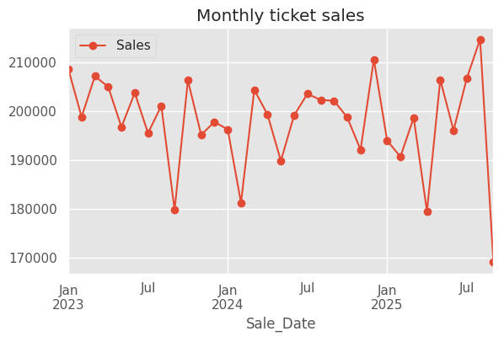
Figure 4: Monthly ticket revenue (sum of ticket prices), January 2023 to September 2025.
Figure 5 confirms the group-by result: Sleeper is the most booked coach type, followed by General and AC.
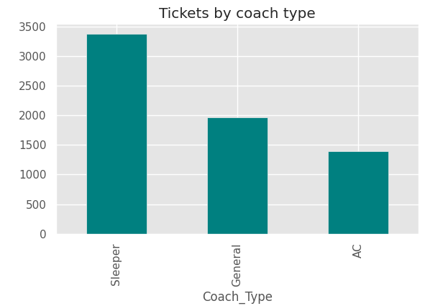
Figure 5: Number of tickets by coach type.
The age histogram in Figure 6 has 15 bins covering the ages from about 5 to 80 years. Every bin holds roughly 415 to 540 passengers, and the last bin (the oldest passengers) is the highest. The distribution is therefore close to uniform: no age group dominates and passengers of every age buy tickets.
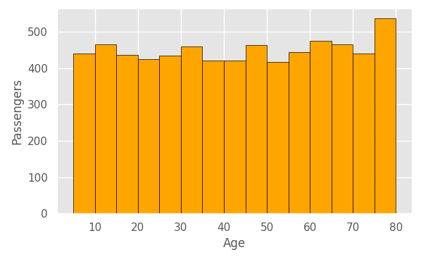
Figure 6: Distribution of passenger age.
In the scatter plot of age against ticket price (Figure 7) the points form three horizontal bands: about Rs. 200–500 (General), Rs. 600–1,200 (Sleeper) and Rs. 1,500–2,500 (AC), with empty gaps between them. Each band extends over the whole age range, so passengers of every age pay similar prices within a coach type. The price is a function of the coach class and not of the age of the passenger.
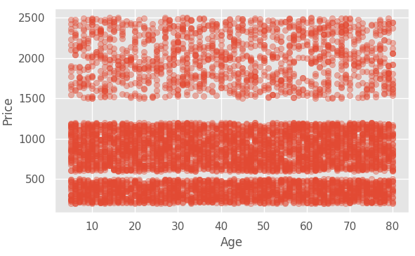
Figure 7: Passenger age versus ticket price.

7.2 Seaborn charts: price and age distributions
The box plot in Figure 8 compares the price distribution of the three coach types. The AC box lies between about Rs. 1,770 and Rs. 2,290 with a median near Rs. 2,000; the Sleeper box lies between about Rs. 740 and Rs. 1,050 with a median near Rs. 890; the General box lies between about Rs. 270 and Rs. 420 with a median near Rs. 350. The three boxes do not overlap, and no outliers are drawn. These values are read from the chart and are approximate.
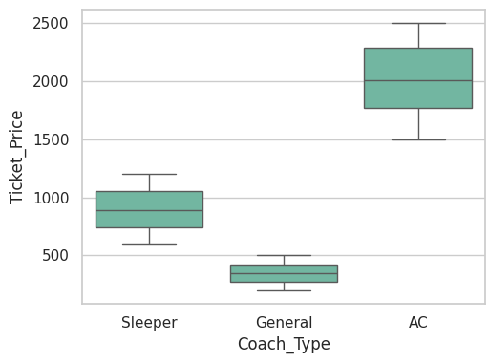
Figure 8: Ticket price by coach type (box plot).
The violin plot in Figure 9 compares the age distribution for each payment mode. The four violins have almost the same shape, spanning the ages from about 5 to 80 years with a median age of about 42 to 44 years. The age profile of passengers is therefore similar for Cash, UPI, Net Banking and Card payments.
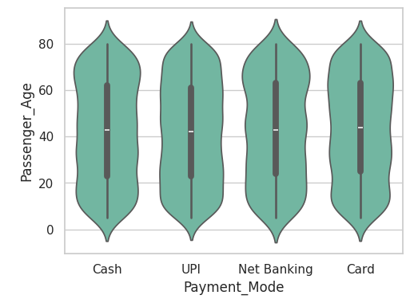
Figure 9: Passenger age by payment mode (violin plot).

7.3 Route heat map
A pivot table counts the tickets for every pair of source and destination station, and sns.heatmap draws it as a colour-coded matrix (Figure 10). The rows are the source stations and the columns the destination stations; the diagonal is empty because journeys with the same source and destination were removed. The darkest cells are the routes between Chennai, Delhi and Mumbai (314 to 337 tickets); the lightest cells are routes between the smaller stations Bengaluru, Gorakhpur, Jaipur and Kolkata (77 to 98 tickets). Section 8 analyses the route counts in detail.
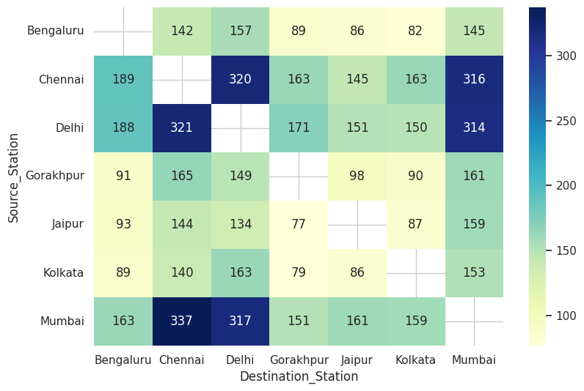
Figure 10: Heat map of the number of tickets by source and destination station.

7.4 Pair plot
The pair plot in Figure 11 shows passenger age and ticket price for the three coach types. On the diagonal the age densities of the three coach types are similar and almost flat between 5 and 80 years, while the price densities form three separate clusters: a narrow one near Rs. 350 for General, a broad one between Rs. 600 and Rs. 1,200 for Sleeper and a broad one between Rs. 1,500 and Rs. 2,500 for AC. The scatter panels again show that the price bands are independent of age. The pair plot therefore agrees with the box plot and the scatter plot.
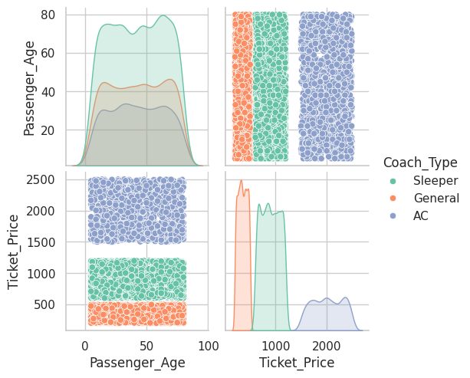
Figure 11: Pair plot of passenger age and ticket price by coach type.

8. Station and Route Demand Analysis
As an additional analysis, the route counts of the heat map (Figure 10) were tabulated and summed by station. The 42 directed route counts were read from the notebook heat map and add up to exactly 6,738 tickets, the number of cleaned records, which confirms that they were read correctly. Table 23 gives the complete matrix with the row and column totals.
Table 23: Number of tickets by source (rows) and destination (columns) station
Source \ Destination | Beng. | Chen. | Delhi | Gora. | Jaipur | Kolk. | Mum. | Total
Bengaluru | – | 142 | 157 | 89 | 86 | 82 | 145 | 701
Chennai | 189 | – | 320 | 163 | 145 | 163 | 316 | 1,296
Delhi | 188 | 321 | – | 171 | 151 | 150 | 314 | 1,295
Gorakhpur | 91 | 165 | 149 | – | 98 | 90 | 161 | 754
Jaipur | 93 | 144 | 134 | 77 | – | 87 | 159 | 694
Kolkata | 89 | 140 | 163 | 79 | 86 | – | 153 | 710
Mumbai | 163 | 337 | 317 | 151 | 161 | 159 | – | 1,288
Total | 813 | 1,249 | 1,240 | 730 | 727 | 731 | 1,248 | 6,738

Each of the 42 directed routes carries between 77 tickets (Jaipur to Gorakhpur) and 337 tickets (Mumbai to Chennai), with an average of 160.4 tickets per route. Demand is clearly concentrated. The six directed routes among Chennai, Delhi and Mumbai carry 314 to 337 tickets each, together 1,925 tickets or 28.6% of all tickets, although they are only 6 of the 42 routes (14.3%). Table 24 and Figure 12 show the same concentration by station: Chennai, Delhi and Mumbai are each the source of about 1,290 tickets and together of 3,879 tickets (57.6% of all tickets), and the destination of 3,737 tickets (55.5%).
Table 24: Tickets by source and destination station
Station | As source | Share | As destination | Share | Source − destination
Bengaluru | 701 | 10.4% | 813 | 12.1% | −112
Chennai | 1,296 | 19.2% | 1,249 | 18.5% | +47
Delhi | 1,295 | 19.2% | 1,240 | 18.4% | +55
Gorakhpur | 754 | 11.2% | 730 | 10.8% | +24
Jaipur | 694 | 10.3% | 727 | 10.8% | −33
Kolkata | 710 | 10.5% | 731 | 10.8% | −21
Mumbai | 1,288 | 19.1% | 1,248 | 18.5% | +40

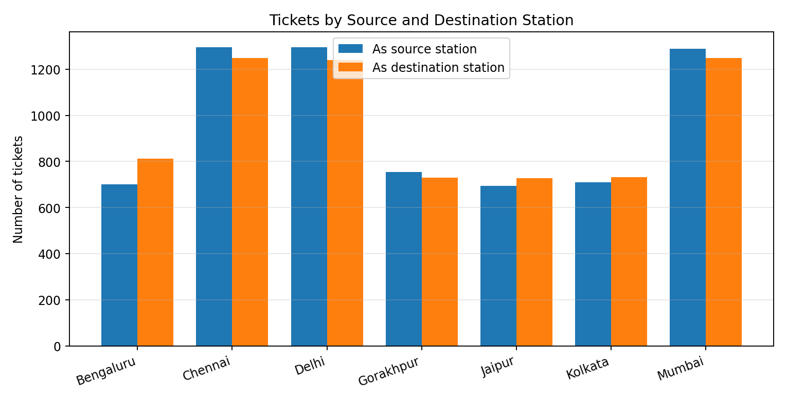
Figure 12: Tickets by source and destination station.
The last column of Table 24 shows the net direction of travel. Bengaluru has more tickets as a destination (813) than as a source (701), a difference of 112 tickets, which is the largest imbalance; Jaipur and Kolkata also have slightly more arrivals than departures, while Chennai, Delhi, Mumbai and Gorakhpur have slightly more departures. The Bengaluru imbalance comes mainly from two routes: Chennai to Bengaluru has 189 tickets against 142 in the opposite direction, and Delhi to Bengaluru has 188 tickets against 157. The differences sum to zero, as they must. Because the dataset records only the tickets sold and not the return journeys, the imbalance shows the direction in which tickets were sold, not the net movement of passengers.
Table 25: Ten busiest directed routes
Rank | Route | Tickets | Share of all tickets
1 | Mumbai - Chennai | 337 | 5.0%
2 | Delhi - Chennai | 321 | 4.8%
3 | Chennai - Delhi | 320 | 4.7%
4 | Mumbai - Delhi | 317 | 4.7%
5 | Chennai - Mumbai | 316 | 4.7%
6 | Delhi - Mumbai | 314 | 4.7%
7 | Chennai - Bengaluru | 189 | 2.8%
8 | Delhi - Bengaluru | 188 | 2.8%
9 | Delhi - Gorakhpur | 171 | 2.5%
10 | Gorakhpur - Chennai | 165 | 2.4%

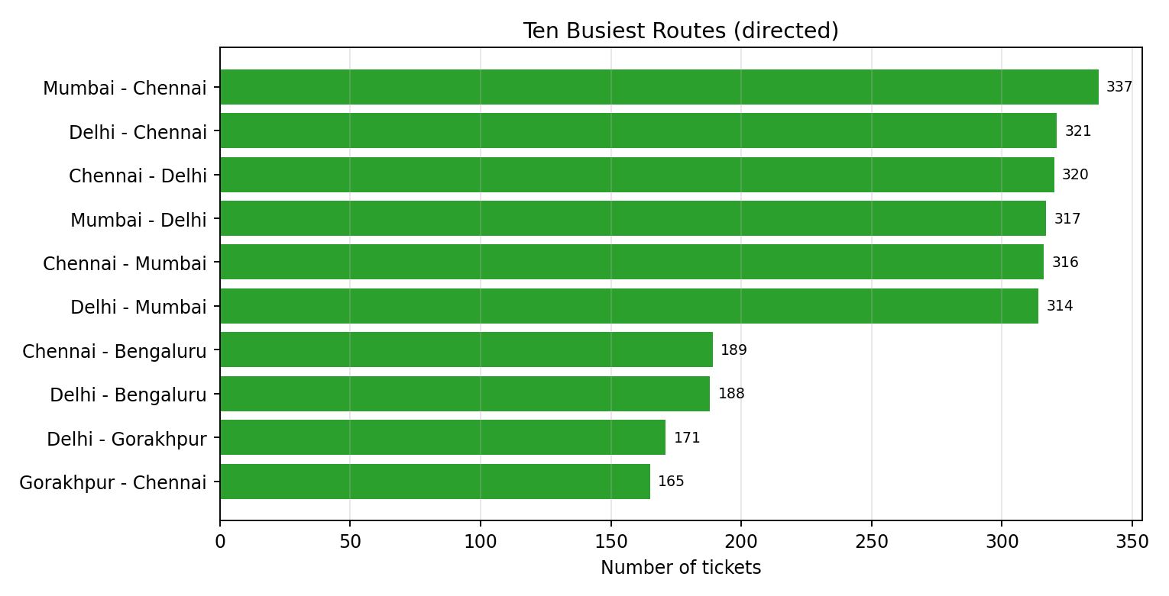
Figure 13: The ten busiest directed routes.
The ten busiest routes confirm a two-tier pattern. The first tier consists of the six routes among Chennai, Delhi and Mumbai with more than 310 tickets each. The second tier begins at 189 tickets, about 40% fewer than the weakest first-tier route (314 tickets), with routes from Chennai and Delhi to Bengaluru and from Delhi to Gorakhpur. Routes that connect only the smaller stations (Bengaluru, Gorakhpur, Jaipur and Kolkata) have the lowest counts, between 77 and 98 tickets. Since the dataset has no distance or train information, these results describe ticket demand only and do not indicate train capacity.

9. Key Findings
- The cleaned dataset holds 6,738 tickets sold between January 2023 and September 2025 after removing 1,262 journeys with the same source and destination (15.8% of 8,000 records); no missing values or repeated rows were found.
- Sleeper is the most booked coach (3,380 tickets, 50.2%), followed by General (1,965; 29.2%) and AC (1,393; 20.7%).
- Ticket price depends on the coach class: mean prices are Rs. 349.82 (General), Rs. 897.84 (Sleeper) and Rs. 2,016.30 (AC), and the three price ranges do not overlap.
- AC contributes 43.0% of the ticket revenue with 20.7% of the tickets; General contributes 10.5% of the revenue with 29.2% of the tickets.
- The overall mean ticket price is Rs. 969.25 and the median Rs. 844; the mean is higher than the median because of the AC tickets.
- Ticket price shows no visible relation to the source station, the passenger age or the payment mode; mean prices differ little between stations within a coach class.
- Passenger age is spread almost evenly between about 5 and 80 years, and the age profile is similar for all four payment modes.
- The Chennai, Delhi and Mumbai routes dominate demand: the six routes among them carry 28.6% of all tickets, and the three cities are the source of 57.6% of tickets.
- Bengaluru has the largest imbalance between tickets sold as destination (813) and as source (701).
- Monthly ticket revenue fluctuates between about Rs. 170,000 and Rs. 215,000 from January 2023 to September 2025, with no clear long-term trend.

10. Recommendations
The following recommendations are general suggestions based on the findings above; they are not results of the notebook.
- Prioritise the high-demand corridors. Capacity planning and passenger services should give first attention to the Delhi–Mumbai–Chennai corridors, with the links from Chennai and Delhi to Bengaluru as the next priority.
- Protect AC availability. AC coaches bring 43.0% of the revenue from 20.7% of the tickets, so changes in the coach mix should be checked against their effect on revenue, while Sleeper and General coaches carry most of the passengers.
- Standardise station coding. Stations were recorded both as names and as codes, and some tickets had the same source and destination. Using one station code and validating the journey at entry would remove most of the cleaning work and the loss of 15.8% of the records.
- Plan services for all ages. Passengers are spread evenly from childhood to old age, so facilities such as lower-berth allocation and assistance should be available on all major routes and not targeted at one age band.
- Record the journey date and train. Adding the journey date, departure time and train number to the ticket data would allow real peak travel periods and train-wise load to be studied; the sale date shows only when the ticket was bought.

11. Limitations
- The dataset has no train number, journey date or time, distance or seat information. Sale_Date is the date of sale and not of travel, so peak travel periods cannot be identified.
- Ticket price depends almost only on the coach class and is spread uniformly inside each class; the price shows no relation to the route or the age. This suggests that the data may be simulated and not taken from real ticketing records; the source of the file should be confirmed.
- Journeys with identical source and destination (1,262 rows, 15.8%) were removed as invalid. This is an assumption; the rows may be a data-entry problem or may represent a different kind of ticket, which would change the route counts.
- Every record has a unique Ticket_ID, so the duplicate check could not detect repeated bookings.
- The currency of the ticket price is not stated; Indian Rupees are assumed.
- The notebook does not print the number of tickets per payment mode or per age group, the weekly mean price, or the exact monthly revenue after May 2023. Values from the box plot, histogram and monthly chart in this report are read from the charts and are approximate.
- The notebook computes no correlation coefficients or statistical tests, so relationships (for example between age and price) are described from charts only.
- The NumPy section of the notebook contains generic array demonstrations, which do not describe passenger travel.

Notebook issues noted
- The cell that prints df.shape, df.dtypes and df.describe() ended with NameError: name “df” is not defined, because it was run before the file was uploaded. Its results are therefore not available and are not used in this report; the row count of 8,000 is taken from the notebook title cell.
- The source of the dataset is a placeholder (“add dataset link here”).
- The notebook uploads the file with google.colab.files.upload() and therefore runs only in Google Colab unless that line is replaced by a file path.
- Some outputs (Section 6.1) were produced before cleaning, so station codes such as SBC and HWH appear in them.

12. Conclusion
Train ticket demand in this dataset depends mainly on the route and the coach class. A small number of routes among Chennai, Delhi and Mumbai carry more than a quarter of all tickets, Sleeper is the most booked coach class and AC is the main source of revenue. Ticket price is set by the coach class and shows no relation to the passenger age, the source station or the payment mode, and passengers of all ages from about 5 to 80 years travel. Monthly ticket revenue fluctuates without a clear trend. The data had few quality problems: inconsistent station codes and labels, and a sixth of the records with the same source and destination. The project shows that careful cleaning, feature engineering, group-wise comparison and simple visualizations turn a table of 6,738 tickets into practical information for railway planning: where passengers travel, in which class and what they pay.

13. Future Scope
- Add journey date, departure time, train number and distance to study real peak travel periods, load per train and price per kilometre.
- Analyse day-of-week and seasonal patterns of ticket sales and forecast monthly demand with a time-series model.
- Build a regression model to predict the ticket price from the coach type, route and age, and a classification model for the coach type.
- Count and compare the tickets per payment mode and per age group, and test the differences with statistical tests.
- Compute the correlation matrix of the numeric variables and test the apparent independence of price and age.
- Cluster stations by their incoming and outgoing demand to support network planning.
- Build a Streamlit or Dash dashboard so that non-technical users can explore the routes and prices.

References
- The pandas development team. pandas documentation. https://pandas.pydata.org
- McKinney, W. Data structures for statistical computing in Python. Proceedings of the 9th Python in Science Conference, 2010.
- Harris, C. R. et al. Array programming with NumPy. Nature 585, 2020. https://numpy.org
- Hunter, J. D. Matplotlib documentation. https://matplotlib.org
- Waskom, M. L. seaborn: statistical data visualization. Journal of Open Source Software 6(60), 3021, 2021. https://seaborn.pydata.org
- Tukey, J. W. Exploratory Data Analysis. Addison-Wesley, 1977.
- Add: original publisher, link and access date of train_ticket_sales_india.csv (the notebook contains only the placeholder “add dataset link here”).

Appendix A – Notebook (ipynb) File
The complete notebook edavproject112.ipynb is reproduced below with its code and outputs. The dataset is loaded in Google Colab with files.upload() followed by pd.read_csv. The cell that prints the shape, data types and summary statistics ended with a NameError and is reproduced as recorded. Plots appear as images; wide tables are reproduced in a small monospaced font.
Train Passenger Travel Pattern Analysis
Dataset: Train Ticket Sales India (train_ticket_sales_india.csv), 8000 ticket records, Jan 2023 to Sep 2025
Source: (add dataset link here)
import numpy as np
import pandas as pd
import matplotlib.pyplot as plt
import seaborn as sns
from google.colab import files

up = files.upload()
df = pd.read_csv(list(up.keys())[0])
df.head()
Saving train_ticket_sales_india (1).csv to train_ticket_sales_india (1) (1).csv
Ticket_ID Sale_Date Source_Station Destination_Station Passenger_Age \
0 1 2023-01-01 SBC Delhi 24
1 2 2023-01-01 Mumbai Chennai 46
2 3 2023-01-01 SBC Mumbai 76
3 4 2023-01-01 BCT HWH 38
4 5 2023-01-01 Delhi Delhi 54

Coach_Type Ticket_Price Payment_Mode
0 Sleeper 1065 Cash
1 General 338 Cash
2 General 420 UPI
3 Sleeper 872 UPI
4 AC 1653 UPI

print(df.shape)
print(df.dtypes)
df.describe()
NameError: name 'df' is not defined

Pandas basics
prices = pd.Series(df['Ticket_Price'].head(5).values, index=['t1', 't2', 't3', 't4', 't5'])
print(prices)
coach = pd.DataFrame({'Coach_Type': ['General', 'Sleeper', 'AC'], 'Level': [1, 2, 3]})
coach
t1 1065
t2 338
t3 420
t4 872
t5 1653
dtype: int64
Coach_Type Level
0 General 1
1 Sleeper 2
2 AC 3

print(df.loc[0:4, ['Source_Station', 'Destination_Station', 'Ticket_Price']])
print(df.iloc[:5, :4])
df[df['Ticket_Price'] > df['Ticket_Price'].mean()].head()
Source_Station Destination_Station Ticket_Price
0 SBC Delhi 1065
1 Mumbai Chennai 338
2 SBC Mumbai 420
3 BCT HWH 872
4 Delhi Delhi 1653
Ticket_ID Sale_Date Source_Station Destination_Station
0 1 2023-01-01 SBC Delhi
1 2 2023-01-01 Mumbai Chennai
2 3 2023-01-01 SBC Mumbai
3 4 2023-01-01 BCT HWH
4 5 2023-01-01 Delhi Delhi
Ticket_ID Sale_Date Source_Station Destination_Station Passenger_Age \
0 1 2023-01-01 SBC Delhi 24
4 5 2023-01-01 Delhi Delhi 54
5 6 2023-01-01 Mumbai SBC 15
6 7 2023-01-01 HWH Gorakhpur 47
8 9 2023-01-01 MAS Mumbai 12

Coach_Type Ticket_Price Payment_Mode
0 Sleeper 1065 Cash
4 AC 1653 UPI
5 AC 1748 Cash
6 AC 1778 UPI
8 Sleeper 1113 NetBanking

Cleaning
print(df.isnull().sum())
df['Passenger_Age'] = df['Passenger_Age'].fillna(df['Passenger_Age'].median())
df = df.dropna(subset=['Ticket_Price'])
codes = {'BCT': 'Mumbai', 'MAS': 'Chennai', 'NDLS': 'Delhi', 'HWH': 'Kolkata', 'SBC': 'Bengaluru'}
df['Source_Station'] = df['Source_Station'].replace(codes)
df['Destination_Station'] = df['Destination_Station'].replace(codes)
df['Payment_Mode'] = df['Payment_Mode'].replace({'NetBanking': 'Net Banking'})
df['Sale_Date'] = pd.to_datetime(df['Sale_Date'])
df['Ticket_Price'] = df['Ticket_Price'].astype(float)
print(df.duplicated().sum())
df = df.drop_duplicates()
df = df[df['Source_Station'] != df['Destination_Station']]
df.shape
Ticket_ID 0
Sale_Date 0
Source_Station 0
Destination_Station 0
Passenger_Age 0
Coach_Type 0
Ticket_Price 0
Payment_Mode 0
dtype: int64
0
(6738, 8)

Transformation
df['Pay_Code'] = df['Payment_Mode'].map({'Cash': 0, 'UPI': 1, 'Card': 2, 'Net Banking': 3})
df['Route'] = df['Source_Station'] + ' - ' + df['Destination_Station']
df.rename(columns={'Ticket_Price': 'Price'}).head(3)
Ticket_ID Sale_Date Source_Station Destination_Station Passenger_Age \
0 1 2023-01-01 Bengaluru Delhi 24
1 2 2023-01-01 Mumbai Chennai 46
2 3 2023-01-01 Bengaluru Mumbai 76

Coach_Type Price Payment_Mode Pay_Code Route
0 Sleeper 1065.0 Cash 0 Bengaluru - Delhi
1 General 338.0 Cash 0 Mumbai - Chennai
2 General 420.0 UPI 1 Bengaluru - Mumbai

df['Age_Group'] = pd.cut(df['Passenger_Age'], bins=[0, 18, 35, 60, 100], labels=['Child', 'Young', 'Adult', 'Senior'])
df['Price_Level'] = pd.qcut(df['Ticket_Price'], 3, labels=['Low', 'Medium', 'High'])
df['Price_Rank'] = df['Ticket_Price'].rank(ascending=False)
df.sort_values('Ticket_Price', ascending=False).head()
Ticket_ID Sale_Date Source_Station Destination_Station Passenger_Age \
7590 7591 2025-08-04 Gorakhpur Delhi 32
4745 4746 2024-08-15 Gorakhpur Jaipur 27
2421 2422 2023-10-30 Delhi Jaipur 14
7801 7802 2025-08-31 Delhi Mumbai 61
2118 2119 2023-09-22 Chennai Gorakhpur 31

Coach_Type Ticket_Price Payment_Mode Pay_Code Route \
7590 AC 2500.0 Cash 0 Gorakhpur - Delhi
4745 AC 2500.0 Net Banking 3 Gorakhpur - Jaipur
2421 AC 2500.0 Cash 0 Delhi - Jaipur
7801 AC 2499.0 Cash 0 Delhi - Mumbai
2118 AC 2499.0 Cash 0 Chennai - Gorakhpur

Age_Group Price_Level Price_Rank
7590 Young High 2.0
4745 Young High 2.0
2421 Child High 2.0
7801 Senior High 5.0
2118 Young High 5.0

df.query("Age_Group == 'Senior' and Price_Level == 'High'").head()
Ticket_ID Sale_Date Source_Station Destination_Station Passenger_Age \
31 32 2023-01-04 Kolkata Jaipur 71
36 37 2023-01-05 Mumbai Delhi 69
38 39 2023-01-05 Mumbai Chennai 68
42 43 2023-01-06 Jaipur Chennai 77
46 47 2023-01-06 Gorakhpur Mumbai 61

Coach_Type Ticket_Price Payment_Mode Pay_Code Route \
31 AC 1860.0 UPI 1 Kolkata - Jaipur
36 Sleeper 1055.0 Net Banking 3 Mumbai - Delhi
38 Sleeper 1065.0 UPI 1 Mumbai - Chennai
42 AC 1972.0 UPI 1 Jaipur - Chennai
46 Sleeper 1121.0 Card 2 Gorakhpur - Mumbai

Age_Group Price_Level Price_Rank
31 Senior High 920.5
36 Senior High 2226.0
38 Senior High 2156.0
42 Senior High 772.5
46 Senior High 1867.5

Indexing and merging
multi = df.set_index(['Source_Station', 'Destination_Station']).sort_index()
multi.loc['Delhi'].head()
Ticket_ID Sale_Date Passenger_Age Coach_Type \
Destination_Station
Bengaluru 12 2023-01-02 69 General
Bengaluru 56 2023-01-07 68 General
Bengaluru 100 2023-01-13 75 AC
Bengaluru 137 2023-01-17 68 Sleeper
Bengaluru 278 2023-02-04 34 Sleeper

Ticket_Price Payment_Mode Pay_Code Route \
Destination_Station
Bengaluru 329.0 Cash 0 Delhi - Bengaluru
Bengaluru 232.0 UPI 1 Delhi - Bengaluru
Bengaluru 2197.0 Cash 0 Delhi - Bengaluru
Bengaluru 714.0 Card 2 Delhi - Bengaluru
Bengaluru 916.0 Cash 0 Delhi - Bengaluru

Age_Group Price_Level Price_Rank
Destination_Station
Bengaluru Senior Low 5882.5
Bengaluru Senior Low 6516.0
Bengaluru Senior High 447.0
Bengaluru Senior Medium 4082.5
Bengaluru Young Medium 2963.0

both = pd.concat([df.head(3), df.tail(3)])
merged = df.merge(coach, on='Coach_Type', how='left')
print(both.shape, merged.shape)
merged[['Coach_Type', 'Level']].head()
(6, 13) (6738, 14)
Coach_Type Level
0 Sleeper 2
1 General 1
2 General 1
3 Sleeper 2
4 AC 3

g = df.groupby(['Source_Station', 'Coach_Type'])['Ticket_Price'].mean().reset_index()
pv = g.pivot(index='Source_Station', columns='Coach_Type', values='Ticket_Price')
st = pv.stack()
print(pv.round(0))
print(st.head())
st.unstack().head()
Coach_Type AC General Sleeper
Source_Station
Bengaluru 2005.0 346.0 896.0
Chennai 2052.0 346.0 909.0
Delhi 2013.0 349.0 899.0
Gorakhpur 1998.0 352.0 894.0
Jaipur 2014.0 357.0 894.0
Kolkata 2014.0 349.0 899.0
Mumbai 2003.0 352.0 891.0
Source_Station Coach_Type
Bengaluru AC 2005.417219
General 345.950249
Sleeper 895.873926
Chennai AC 2052.236641
General 346.183623
dtype: float64
Coach_Type AC General Sleeper
Source_Station
Bengaluru 2005.417219 345.950249 895.873926
Chennai 2052.236641 346.183623 909.066561
Delhi 2012.886861 348.561308 898.848624
Gorakhpur 1997.617450 352.352941 894.453865
Jaipur 2014.465278 357.305000 893.837143

Groupby and time series
print(df.groupby('Coach_Type')['Ticket_Price'].agg(['count', 'mean', 'max']))
df.groupby(['Payment_Mode', 'Age_Group'], observed=True)['Ticket_Price'].mean().unstack()
count mean max
Coach_Type
AC 1393 2016.301508 2500.0
General 1965 349.820865 500.0
Sleeper 3380 897.840237 1200.0
Age_Group Child Young Adult Senior
Payment_Mode
Card 1015.246057 946.654596 1011.511464 978.213983
Cash 956.168790 1003.047120 899.169231 965.963675
Net Banking 963.487288 1024.539286 943.840796 958.693151
UPI 922.061224 970.359140 987.613670 969.410646

ts = df.set_index('Sale_Date').sort_index()
monthly = ts['Ticket_Price'].resample('ME').sum()
weekly = ts['Ticket_Price'].resample('W').mean()
print(monthly.head())
ts.loc['2024-01':'2024-03'].head()
Sale_Date
2023-01-31 208642.0
2023-02-28 198804.0
2023-03-31 207156.0
2023-04-30 204980.0
2023-05-31 196739.0
Freq: ME, Name: Ticket_Price, dtype: float64
Ticket_ID Source_Station Destination_Station Passenger_Age \
Sale_Date
2024-01-01 2927 Mumbai Jaipur 20
2024-01-01 2928 Chennai Jaipur 17
2024-01-01 2929 Delhi Mumbai 15
2024-01-01 2930 Chennai Mumbai 6
2024-01-01 2931 Jaipur Delhi 23

Coach_Type Ticket_Price Payment_Mode Pay_Code Route \
Sale_Date
2024-01-01 General 437.0 Card 2 Mumbai - Jaipur
2024-01-01 General 402.0 UPI 1 Chennai - Jaipur
2024-01-01 General 446.0 Net Banking 3 Delhi - Mumbai
2024-01-01 Sleeper 1192.0 Card 2 Chennai - Mumbai
2024-01-01 Sleeper 955.0 Net Banking 3 Jaipur - Delhi

Age_Group Price_Level Price_Rank
Sale_Date
2024-01-01 Young Low 5195.5
2024-01-01 Child Low 5422.5
2024-01-01 Child Low 5135.5
2024-01-01 Child High 1443.5
2024-01-01 Young Medium 2762.0

Matplotlib
plt.style.use('ggplot')
fig, ax = plt.subplots(2, 2, figsize=(12, 8))
monthly.plot(ax=ax[0, 0], marker='o', label='Sales')
ax[0, 0].set_title('Monthly ticket sales')
ax[0, 0].legend()
df['Coach_Type'].value_counts().plot(kind='bar', ax=ax[0, 1], color='teal')
ax[0, 1].set_title('Tickets by coach type')
ax[1, 0].hist(df['Passenger_Age'], bins=15, color='orange', edgecolor='black')
ax[1, 0].set_xlabel('Age')
ax[1, 0].set_ylabel('Passengers')
ax[1, 1].scatter(df['Passenger_Age'], df['Ticket_Price'], alpha=0.4)
ax[1, 1].set_xlabel('Age')
ax[1, 1].set_ylabel('Price')
plt.tight_layout()
plt.show()
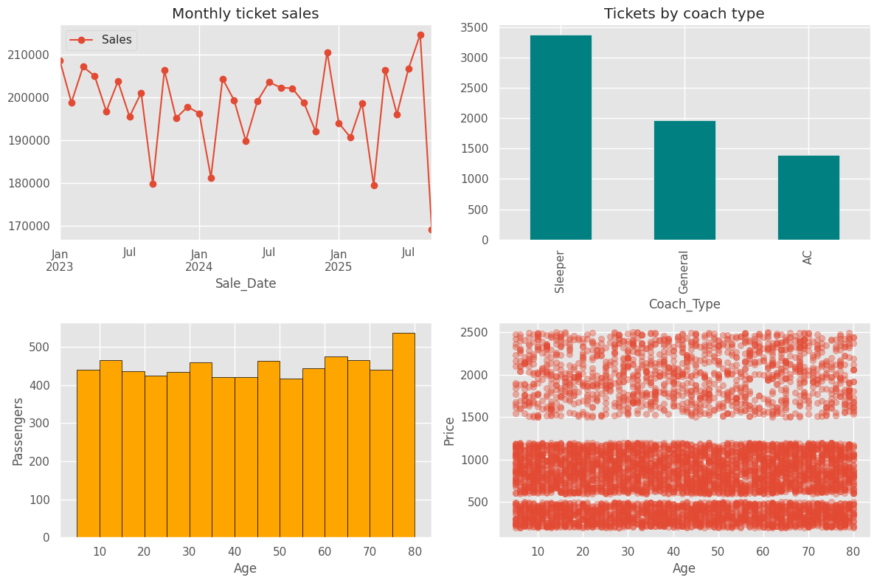

Seaborn
sns.set_theme(style='whitegrid', palette='Set2')
fig, ax = plt.subplots(1, 2, figsize=(12, 4))
sns.boxplot(data=df, x='Coach_Type', y='Ticket_Price', ax=ax[0])
sns.violinplot(data=df, x='Payment_Mode', y='Passenger_Age', ax=ax[1])
plt.show()
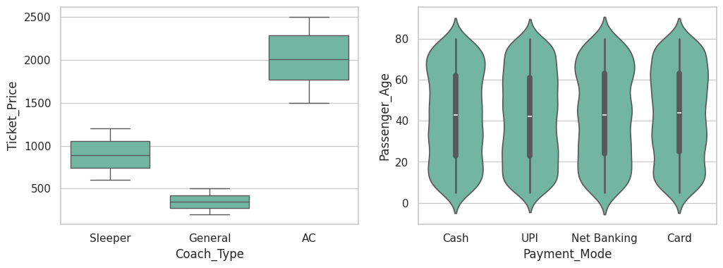

routes = df.pivot_table(index='Source_Station', columns='Destination_Station', values='Ticket_ID', aggfunc='count')
plt.figure(figsize=(9, 6))
sns.heatmap(routes, annot=True, fmt='.0f', cmap='YlGnBu')
plt.show()
sns.pairplot(df[['Passenger_Age', 'Ticket_Price', 'Coach_Type']], hue='Coach_Type')
plt.show()

NumPy
price = df['Ticket_Price'].to_numpy()
a1 = np.arange(1, 10)
a2 = a1.reshape(3, 3)
a3 = np.arange(24).reshape(2, 3, 4)
print(a2[1, :], a2[:2, 1:], a3[1, 2, 3])
print(a2 + np.array([10, 20, 30]))
print(a2 @ a2.T)
print(a2.T)
[4 5 6] [[2 3]
[5 6]] 23
[[11 22 33]
[14 25 36]
[17 28 39]]
[[ 14 32 50]
[ 32 77 122]
[ 50 122 194]]
[[1 4 7]
[2 5 8]
[3 6 9]]

np.random.seed(1)
sample = np.random.choice(price, 50)
print(np.random.randint(1, 100, 5), np.random.rand(3))
print(price.mean(), np.median(price), price.std(), price.max())
print(a2.sum(axis=0), a2.mean(axis=1))
(price - price.mean()) / price.std()
[ 4 71 22 50 58] [0.1975509 0.28962964 0.14212014]
969.2499257940042 844.0 613.4104603486054 2500.0
[12 15 18] [2. 5. 8.]
array([ 0.15609462, -1.02908243, -0.89540359, ..., 0.286513 ,
-0.88073152, 1.32496937])

Appendix B – How to Run

B.1 Running the notebook
- Open edavproject112.ipynb in Google Colab (the notebook imports google.colab.files).
- Run the cells from the top (Runtime → Run all). When the upload cell runs, select train_ticket_sales_india.csv; the notebook reads the first uploaded file, so the file name does not matter.
- The libraries required are NumPy, pandas, Matplotlib and Seaborn, which are pre-installed in Google Colab. The monthly resampling uses the alias "ME", which needs pandas 2.2 or later.
- All tables and charts are produced inside the notebook; the cells must be run in order, because the cell that prints df.shape and df.describe() needs the data frame df created by the upload cell.
- To run the notebook outside Google Colab, delete the import of google.colab and replace the upload cell by df = pd.read_csv("train_ticket_sales_india.csv").

